PHASE 2
Requirements Analysis
Script-Controlled ACL – Restrict Record Access Based on Field Value
Field | Details
Date | 30.9.2026
Team ID | 6ab4dcafa238dc999eb5d928
Project Name | Script-Controlled ACL – Restrict Record Access Based on Field Value
Platform | ServiceNow (Global scope)
Custom Table | Institution Details (u_institution_details)

Purpose
This phase identifies the functional, role-based, data, security and non-functional requirements needed to implement and verify the script-controlled ACL project in ServiceNow, and traces each requirement to its implementation evidence.
REQUIREMENTS ANALYSIS
Project: Script-Controlled ACL – Restrict Record Access Based on Field Value
This requirements analysis identifies the functional, role-based, data, security, and platform requirements needed to implement and verify the ServiceNow ACL project. The analysis follows the project scenario in the supplied documentation.
1. Functional Requirements
ID | Requirement | Description
FR-01 | User & role setup | Create the required test user and custom roles for access control.
FR-02 | Institution Details table | Create the u_institution_details table for student/institution records.
FR-03 | Student fields | Maintain Student Roll Number, Student Name, Faculty Name, Branch, Email, Phone Number and Description.
FR-04 | Student records | Create records with branch values such as ECE, EEE and CSE.
FR-05 | READ ACL | Use script-controlled logic to restrict record visibility based on the configured access condition.
FR-06 | CREATE ACL | Allow record creation through the bb2 role.
FR-07 | WRITE ACL | Allow record modification through the bb3 role.
FR-08 | DELETE ACL | Allow record deletion through the bb4 role.
FR-09 | Administrator access | Administrator retains full access to the records.
FR-10 | Verification | Verify authorized, unauthorized and administrator access behavior.
2. User, Role & Access Requirements
User / Role | Operation | Requirement
bb1 | READ | Authorized records can be viewed according to the READ control.
bb2 | CREATE | Authorized user can create records.
bb3 | WRITE | Authorized user can edit records.
bb4 | DELETE | Authorized user can delete records.
admin | ALL | Administrator has full access.
3. Data Requirements
- The primary custom table is u_institution_details.
- The table must contain the required student and institution-related fields.
- Branch values are used as part of the record-access scenario.
- Records must be available for testing authorized and unauthorized access.
4. Security Requirements
- Access must be controlled through ServiceNow Access Control Lists (ACLs).
- READ access must use script-controlled logic.
- CREATE, WRITE and DELETE operations must be separately controlled.
- Users without the required permission must not receive unauthorized operation access.
- Administrator access must remain unrestricted.
5. Non-Functional Requirements
ID | Category | Requirement
NFR-01 | Security | The ACL configuration must enforce record-level access control.
NFR-02 | Maintainability | READ, CREATE, WRITE and DELETE controls should remain separately identifiable.
NFR-03 | Reliability | Access verification should consistently produce the expected permission behavior.
NFR-04 | Usability | Roles and ACL operations should be understandable for testing and demonstration.
NFR-05 | Traceability | The implementation should be supported by screenshots/evidence of the configured ACLs.
6. Requirements Traceability
Requirement Area | Implementation Evidence
User and roles | User/role creation and role configuration screenshots
Table and fields | Institution Details table and field configuration screenshots
READ security | READ ACL configuration, script and verification screenshots
CREATE security | CREATE ACL configuration screenshot
WRITE security | WRITE ACL and role configuration screenshots
DELETE security | DELETE ACL configuration and verification screenshots
7. IMPLEMENTATION SCREENSHOTS
The following screenshots are included as implementation evidence from the supplied project documentation.
Screenshot 1 – Project scenario and user creation
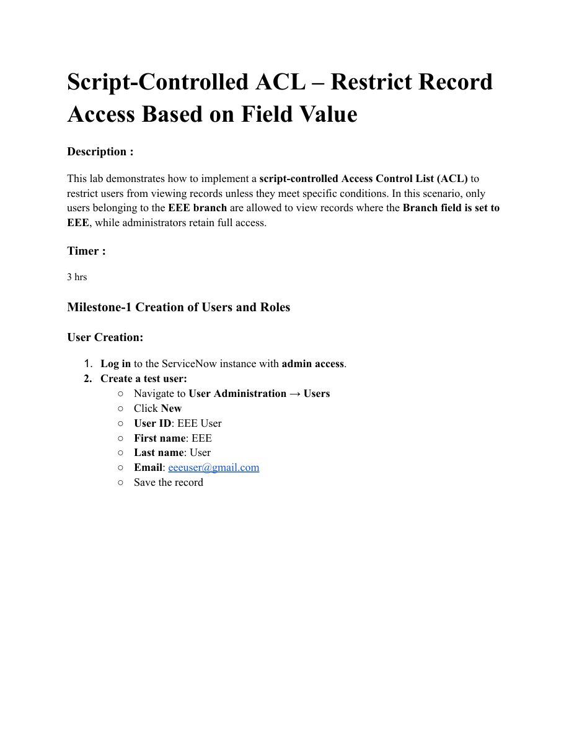
Screenshot 2 – Role creation
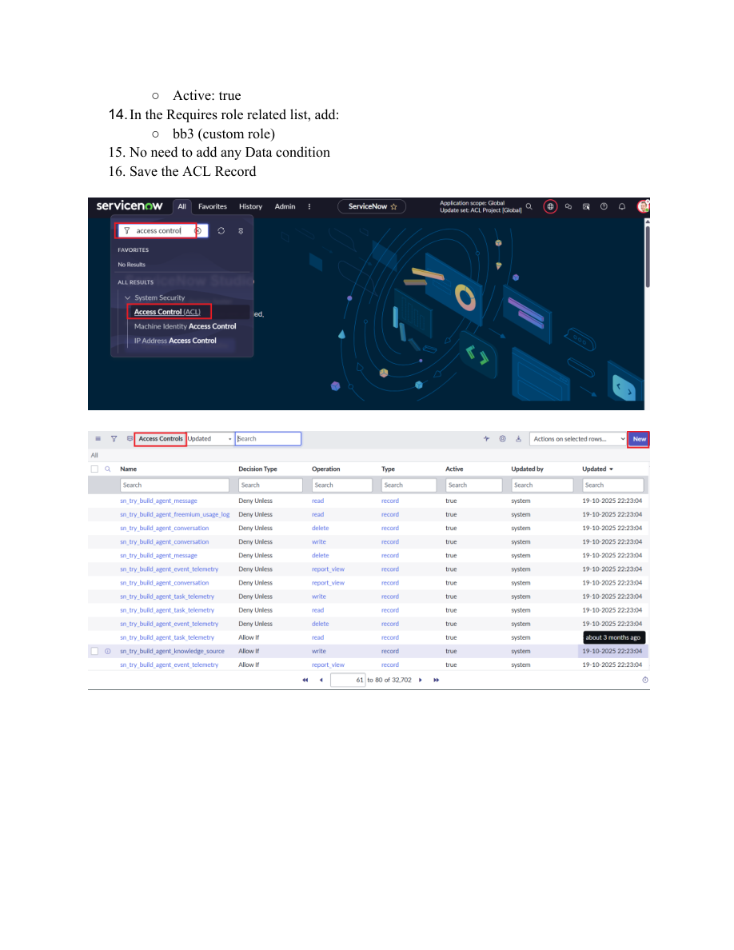
Screenshot 3 – Institution Details table creation
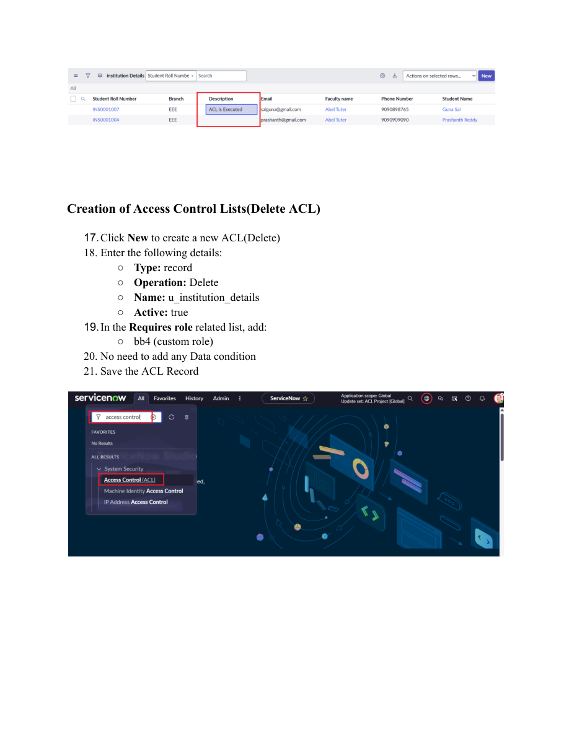
Screenshot 4 – Institution Details field configuration
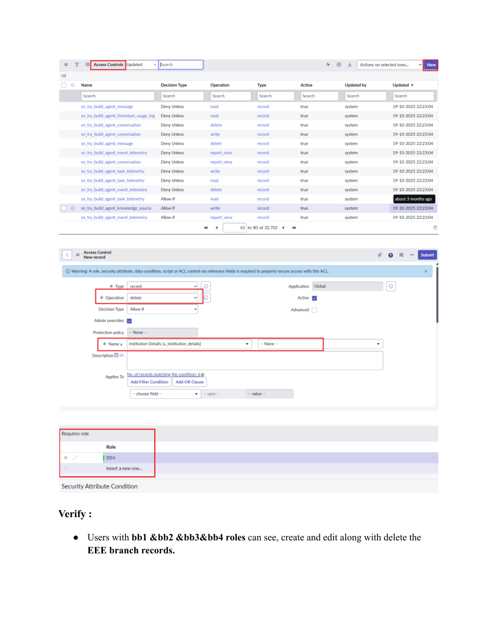
Screenshot 5 – Student records and READ ACL setup
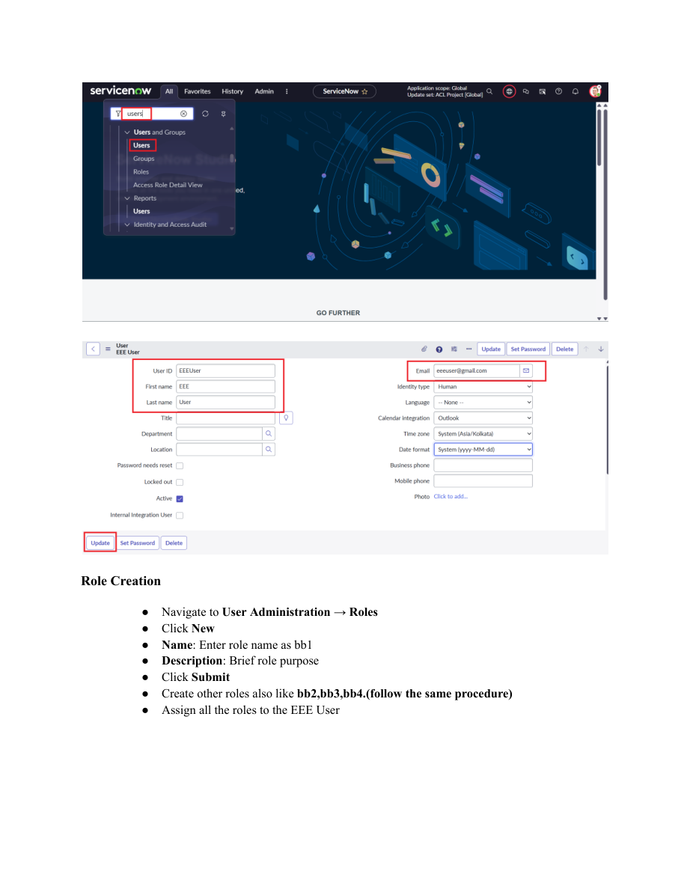
Screenshot 6 – READ ACL script and configuration
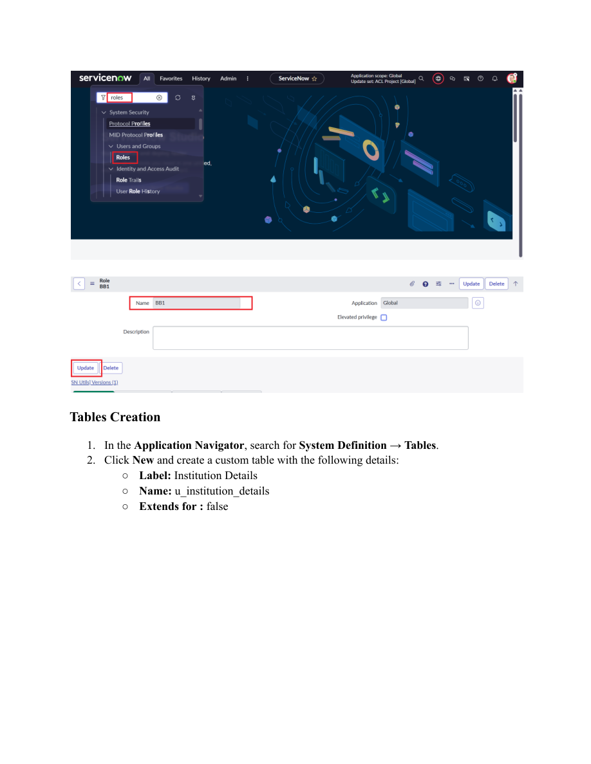
Screenshot 7 – READ ACL verification
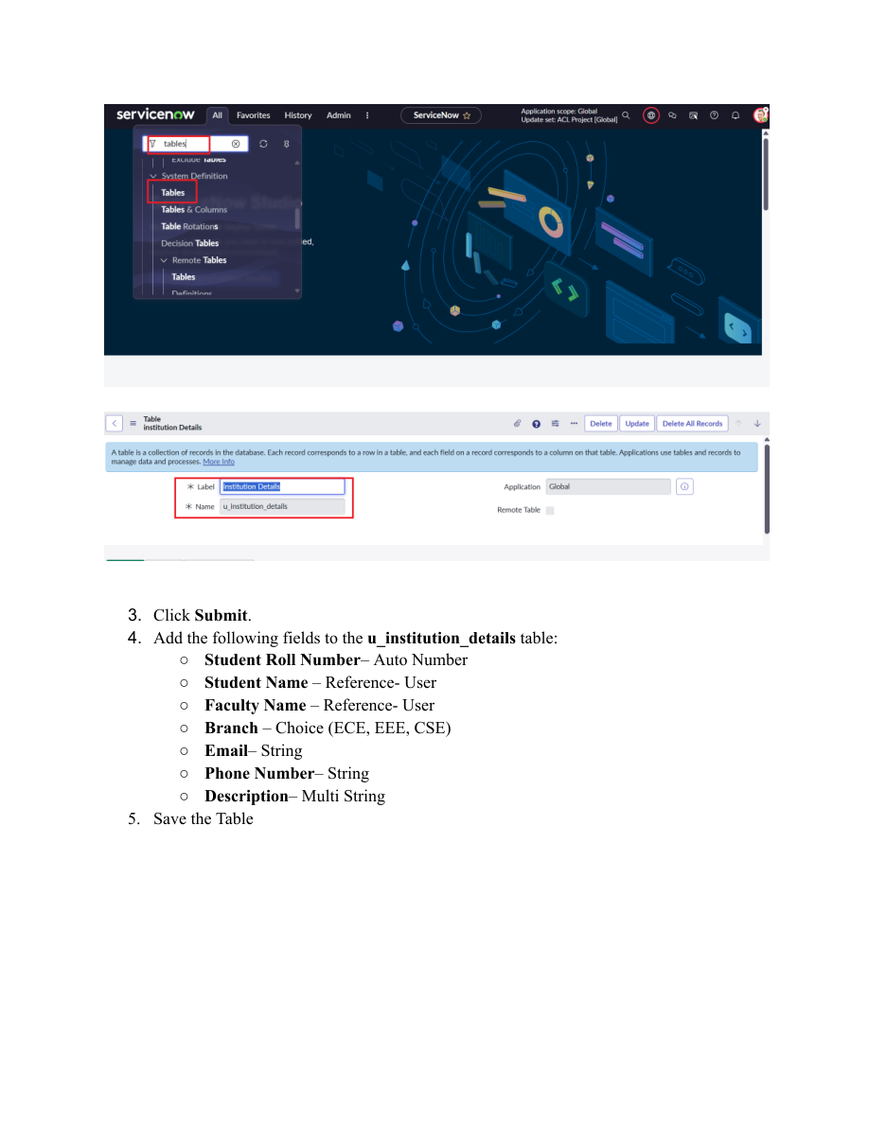
Screenshot 8 – CREATE ACL configuration
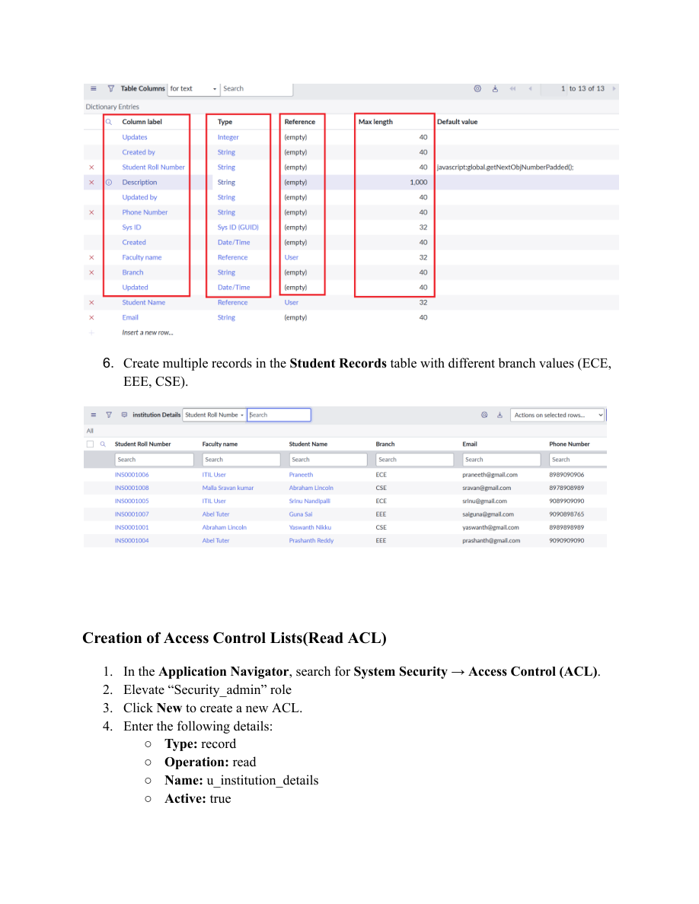
Screenshot 9 – WRITE ACL configuration
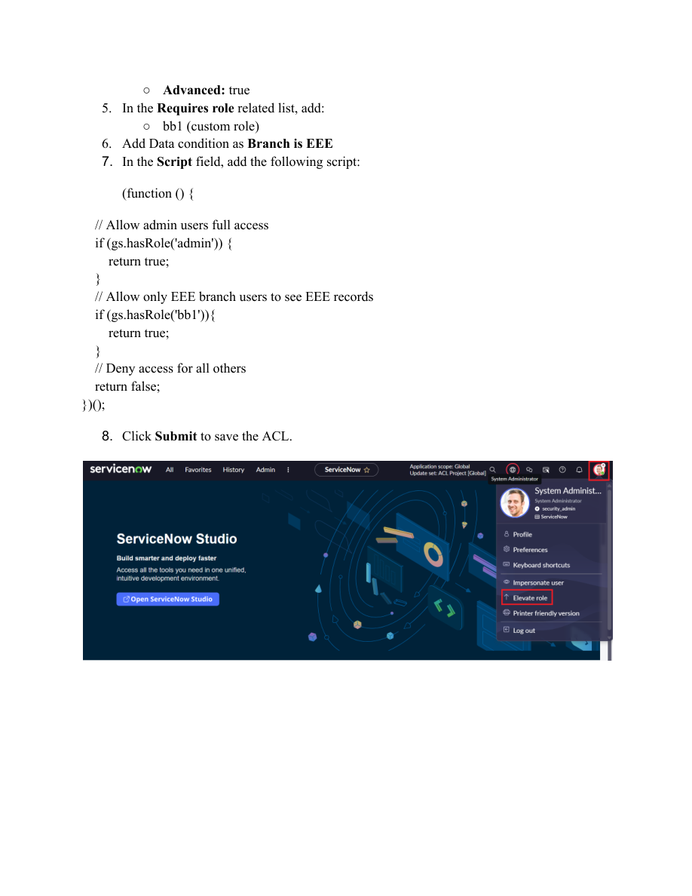
Screenshot 10 – WRITE ACL role configuration
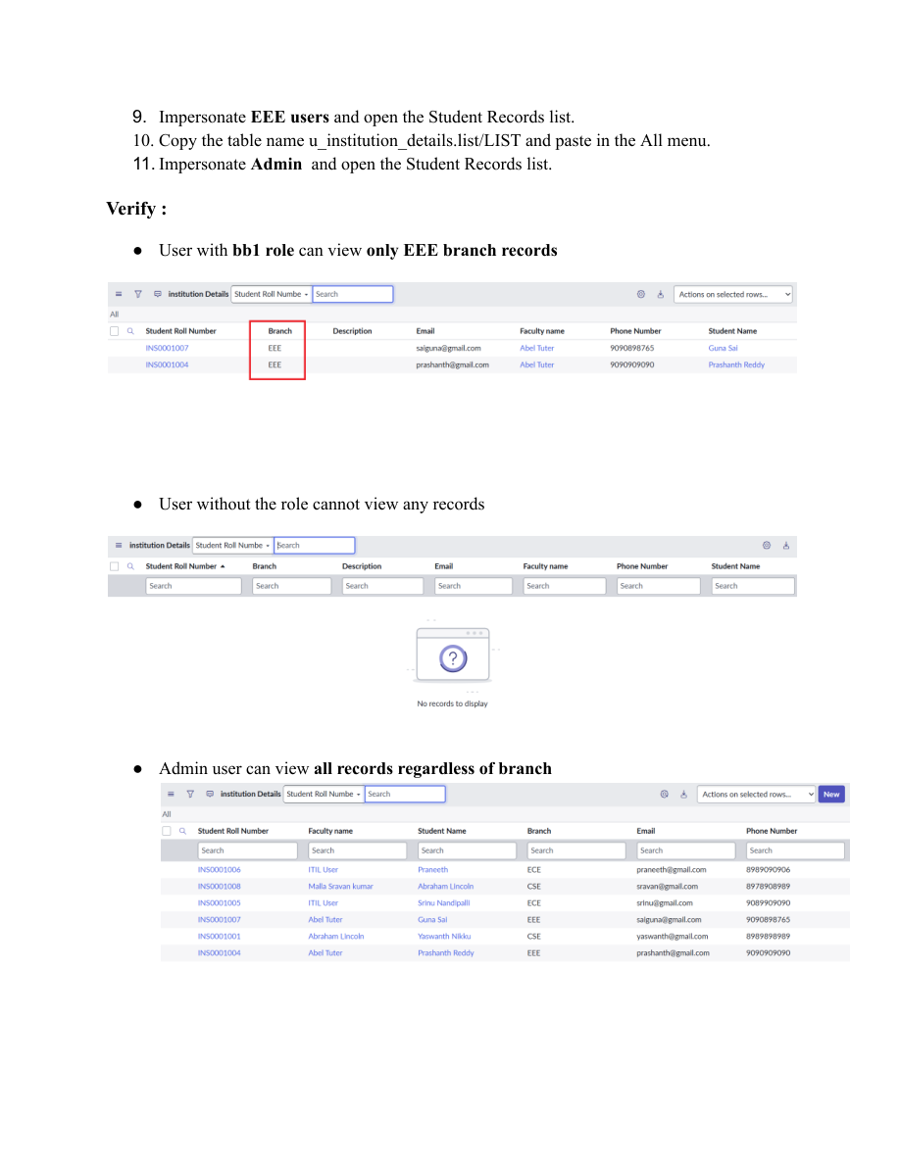
Screenshot 11 – DELETE ACL configuration
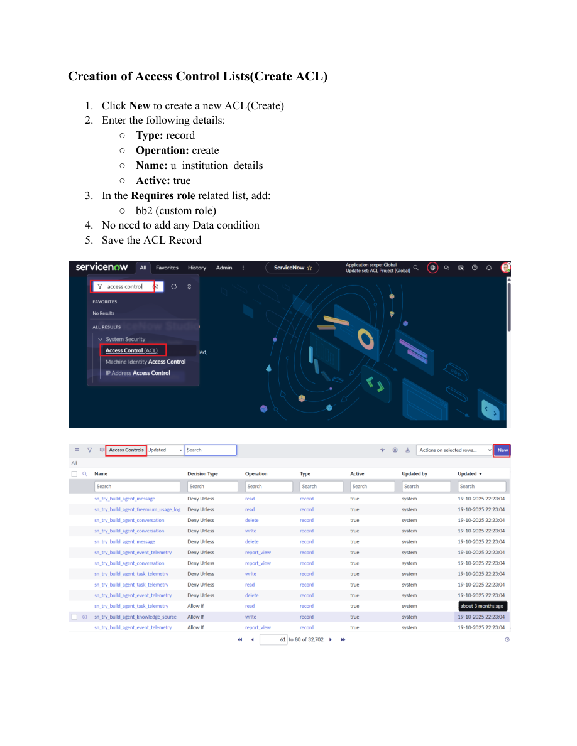
Screenshot 12 – DELETE ACL verification
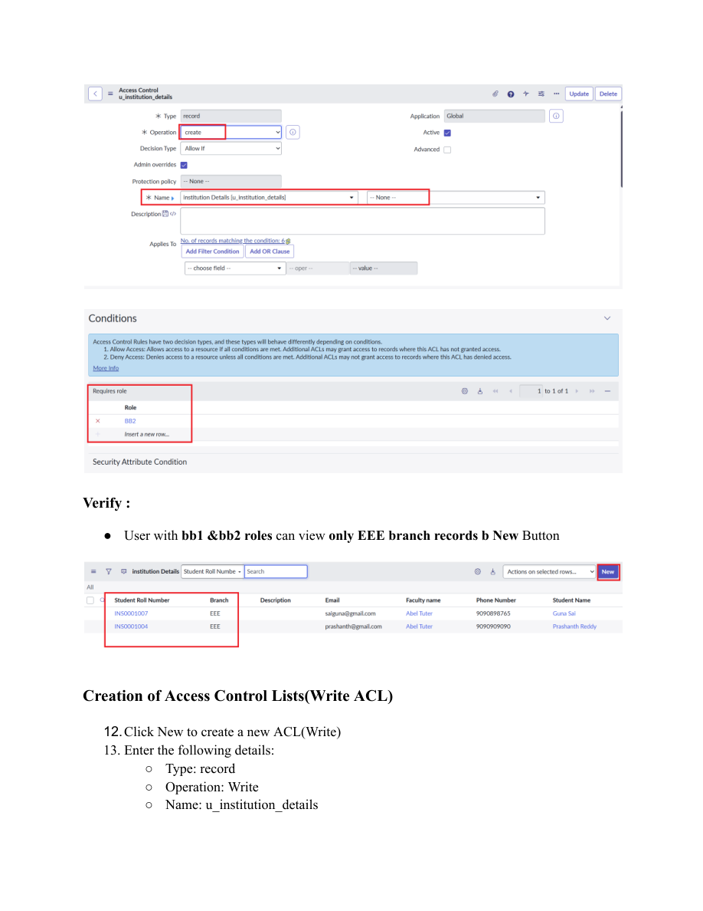
8. REQUIREMENTS ANALYSIS – FINAL SUMMARY
The requirements establish a role-based and script-controlled ACL model for the u_institution_details table. The project separates READ, CREATE, WRITE and DELETE operations and verifies the resulting access behavior using configured roles and records.

